

**Mini-Project Report**

**On**

**“A Virtual Keyboard Implementation Based on Finger Recognition”**

**Submitted to the**

**Dr. Babasaheb Ambedkar Technological University, Lonere.**

**For the Degree of**

**Bachelor of Technology in Computer Science & Engineering**

**By**

|  |  |  |
| --- | --- | --- |
| Sr. No. | PRN No. | Name |
| 1 | 23063211995528 | Akash Subhash Sankanna |
| 2 | 23063211995558 | Rohan Ashok Mushan |
| 3 | 23063211995516 | Riddhesh Virendra Padma |
| 4 | 23063211995527 | Soham Shivswarup Birajdar |

**Under the Guidance of**

Prof. P.S. Pasnur

Department of Artifical Inteligence and Data Science



# V. P. Institute of Engineering and Technology, Solapur

**A.Y. – 2024-25**

**V.V. P. Institute of Engineering and Technology, Solapur** Department of Artificial Inteligence ad Data science



Certificate

This is to certify that the **Mini-Project** entitled **“A Virtual Keyboard implementation based on Finger Recognition”** has been submitted by

|  |  |  |
| --- | --- | --- |
| Sr. No. | PRN No. | Name |
| 1 | 23063211995528 | Mr. Akash Subhash Sankanna |
| 2 | 23063211995558 | Mr. Rohan Ashok Mushan |
| 3 | 23063211995516 | Mr. Riddhesh Virendra Padma |
| 4 | 23063211995527 | Mr. Soham Shivswarup Birajdar |

of AI&DS (T.Y.) class in the partial fulfillment for the award of Degree of Bachelor of Technology.

Prof. P. S. Pasnur Prof. A.G. Mote

**(Course Coordinator) (H. O. D)**

Dr. A. N. Gaikwad

**(Principal**)

**External Examiner**

# ACKNOLEDGEMENT

# 

The compilation of dissertation report on **“A Virtual Keyboard Implementation Based on Finger Recognition”** is the result of the endless help received from number of people. So, it gives me immense pleasure to acknowledge and express my sincere gratitude to those who helped us along my dissertation work.

We would like to express my deep sense of gratitude to our guide **Prof. P.S. Pasnur Mam** for giving mam’s valuable time, precious guidance which helped us in completion of report successfully. We are very much thankful for mam’s moral support and kind cooperation, which mam gave us from time to time and from the start of the Project.

We are also thankful to our Principal **Dr A.N. Gaikwad Sir** and Head of Department **Prof. A.G. Mote Mam** for providing all the necessary facilities. Last but not the least we would like to thank other faculty staff for their direct and indirect contribution and support in completion of this report; Thank You All.

**Content**

|  |  |  |
| --- | --- | --- |
| **Sr. No.** | **Title** | **Page No.** |
| 1 | Abstract | 1 |
| 2 | Introduction | 2 |
| 3 | Requirement Analysis | 4 |
| 5 | Design | 7 |
| 5 | Implementation | 9 |
| 6 | Testing Report | 12 |
| 7 | Performance Analysis | 14 |
| 8 | User Manual | 18 |
| 9 | Result | 20 |
| 10 | Applications | 23 |
| 11 | Bibliography | 26 |

**Introduction**

Image processing is a branch of signal processing that can correspond to input and output images or video tapes as images or their various parameters. Gesture recognition and colorization is an image processing process. Recently, many gesture recognition methods have been proposed. Hand tracking has a variety of operations, including motion capture, human- computer interaction, and human behavior analysis. Different types of detectors and tracking glovesare used for detecting and tracking hand movements.

Instead of using more expensive sensors, simple webcams recognize gestures and track movements. Videoconferencing is all the rage right now. For this reason, most computer users use webcams on their computers, and most laptops have built-in webcams. The proposed webcam-based system may be suitable to eliminate the need for a mouse and keyboard. The process of interacting with a computer using gestures is a really fun and effective method of HCI.

There are many good surveys of this interest. With the increasing development of technology, the size of equipment is becoming more and more compact. Some devices have gone wireless and some devices have been idle. This article proposes a system that can operate some devices in the future, that is, the future of HCI. This offer concerns the development of a virtual mouse and keyboard using gesture recognition.

The end result is to use just a single camera instead of the traditional bias to control mouse cursor and keyboard functions. The virtual mouse only uses the camera as an intermediary between the user and the machine. It helps users interact with machines and control mouse functions without any mechanical or physical bias. Usually we use amouse, keyboard or other very compact way to interact with the computer.

Wireless polarization also requires power and connection technology, but in this article, the user's free hand is the only input option for using the webcam. So it's a really interactive way to control the mouse cursor and the keyboard. The system implicitly replaces typical mouse and machine remote controls. The only obstacle is the lighting conditions. This is why the system is still not good enough to replace a traditional mouse, as most computers are used in low light conditions.

People with severe dyskinesias, in particular, may have physical disabilities that severely limit their ability to control fine motor skills. They may therefore not be suitable for the classroom and communication with a normal keyboard and mouse.

**k-NN Algorithm** :-

*k*-nearest neighbors algorithm ( *k* -NN for short) is a non-parametric machine learning method that is widely used for pattern recognition, data mining, signal processing and regression. In *k*

-NN classification, *k* is a positive value that means the *k* closest training examples were selected to train the sample set. The core concept of *k*-NN algorithm is one of the simplest machine learning algorithms that can be used directly to classify the unknown data.

The training sample is classified into the classes that contain a majority vote of its *k* nearest neighbors. However, *k*-NN algorithm also has two main disadvantages. Firstly, the outcome can be affected when the training examples are not balanced.

For example, if the capacity of a class is very large compared with other classes, they might already occupy most of *k* nearest neighbors. Secondly, the calculation burden is too heavy because the algorithm must compute all distances between an unknown sample and all known training examples to obtain its *k* nearest neighbors.

**Requirement Analysis**

**Software Requirements**

1. **Operating Systems support**

There must be used are windows operating system and android (for application) which will support our functions that we are going to built in our project.

1. **Programming Language**

This project is based on AI concepts, so we choose Python Programming language in our project.

1. **Technical Analysis**

For developing the software we have used Python as programming language because the functionalities for developing the modules of requirement as it can be done easily using it.

The keyboard is an important human-machine interface. Generally, a traditional mechanical keyboard is made up of keys and a Single Chip Microcomputer (SCM). The working principle is that the SCM constantly detects where a key is pressed. Subsequently, the SCM outputs the transmission codes of the corresponding keys to the computer through electrical signals .The CPU then transforms the transmission codes to ASCII codes and save them in the keyboard buffer.

**Design**

1. **Fingertip Recognition subsystem**

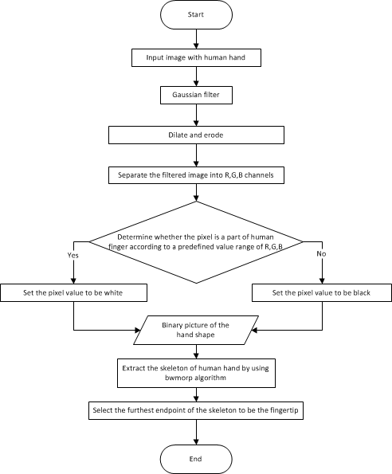

 

**Fig. The flowchart of the fingertip recognition subsystem**

1. **Proposed System**

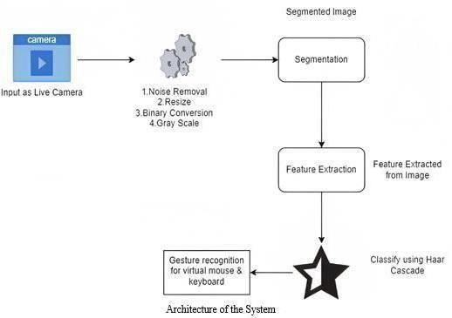

**Fig 2. Proposed System**

1. **Artificial Nueron**

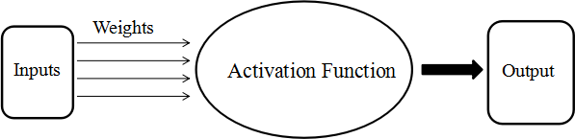

**Fig 3. Artificial Nueron**

**Implementation**

**Proposed Architecture:**

**Language:**

This project is based on the concept of AI, so we choose Python Programmin

**Software Requirements**

* + PyCharm: Python

* + PyCharm SDK
  + Client OS –Windows

**Overall Description:**

For the convenience of experimentation, the experimental data comes from a set of video footages of various typing motions that are filmed by the camera in advance. Three testers are invited to participate in the experiments to test if the virtual keyboard can recognize different hands. Five kinds of paper keyboards are selected to test if the virtual keyboard is customizable and replaceable. To test the usability in a broad spectrum of environments, the testing is conducted in common places such as classrooms and houses. The types of lighting that are used in the experiments are sunlight and lamplight. All paper keyboards are placed on a wall.

**Testing Report**

1. **Unit Testing**

Unit testing focuses each module individually, ensuring that if function properly as unit. In this testing we have tested of our software to ensure maximum error detection. It helps to remove bugs from sub modules & prevent arrival of huge bugs after words

The proposed algorithms used in the virtual keyboard are to locate the virtual keyboard and to extract the fingertip position in each frame . These two algorithms were already introduced in detail .

* **Functional Partitioning:** 
  + 1. Display Keyboard.
    2. Hand Recognition.
    3. Detecting fingers and typing on keyboard.
* **Functional Description:**

1. Name: Display Keyboard. Input:

Open Camera.

Output

Displaying virtual keyboard to type.

**Specification**

This module provides sensing a keyboard for typing. This module also provides alphabets, numbers, special symbol.

2) Name: Hand Recognization

**Input**

With the help of camera recognition hand.

**Output**

Successfully Hand Recognition.

**Specification**

This module provides the virtual keyboard should be able to detect the position, shape, movement of the user’s hand and fingers accurately and reliably.

3) Name: Detecting fingers and typing on keyboard

**Input**

If the Virtual Keyboard is displayed on a touchscreen device.

**Output**

It register the Keystrokes when the user types on the keyboard.

**Specification:**

This module provides the system must have software or hardware that can detect keystrokes on the virtual keyboard. This typically involves software that recognizes when a user clicks on a key and generates the corresponding character or action

1. **Integration Testing**

Integration testing is a systematic technique for constructing the program structure while at the same time conducting tests to uncover errors associated with interfacing. The objective is to take unit tested components and build a program structure that has been dictated by the design.

The Top-down integration testing is an incremental approach to construction of program structure. Modules are integrated by moving downward through the control hierarchy, beginning with the main control module.

Modules subordinate to the main module are incorporated into the structure in depth-first order. Depth-first integration would integrate all components on a major control path of a structure. Selection of a major path is somewhat arbitrary and depends on application-specific characteristics.

1. **Validation Testing**

The purpose of validation testing is to ensure that all expectations of the customer have been satisfied. The testing is done by the project group members by inspecting the requirements and validating each requirement.

We prefer the alpha testing technique for the validation purpose. In which case the a group of students is called on to test the services of IoT. The group members will present at the place and observing the working and collecting the bugs occurring at the site. The changes are made according to the requirements and testing is done again to gather more errors if present

1. **System Testing**

In the system testing system undergoes various exercises to fulfill the system requirements. These tests include: a. Security Tests: these are designed to ensure no user can access the other documents which are none of his business, b. Performance Tests: The tests are conducted to check the performance of the system.

**Performance Analysis**

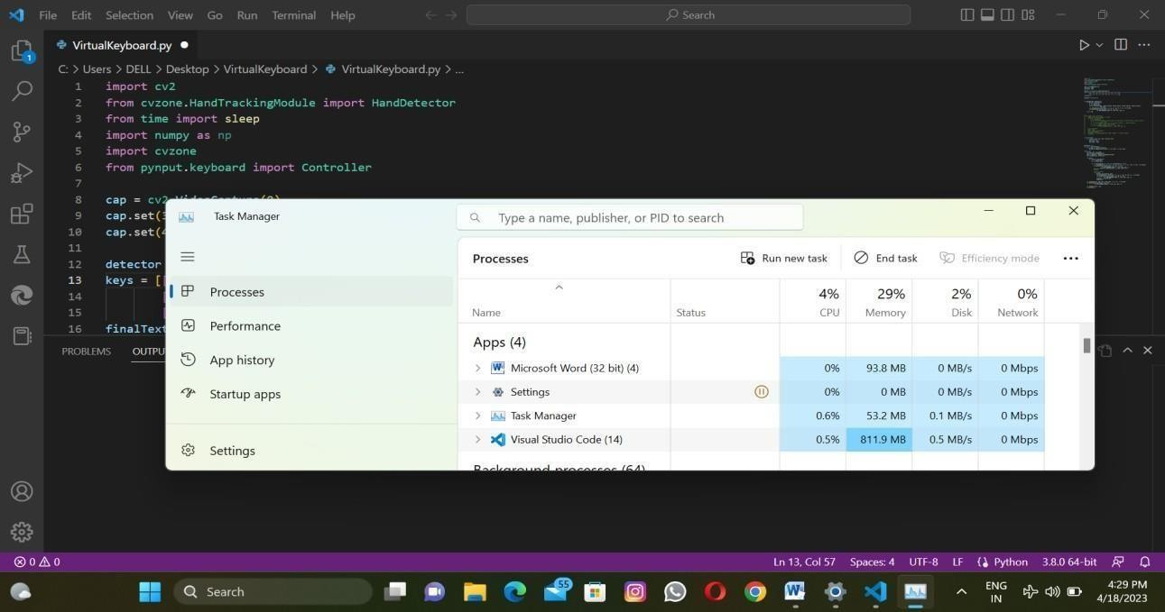

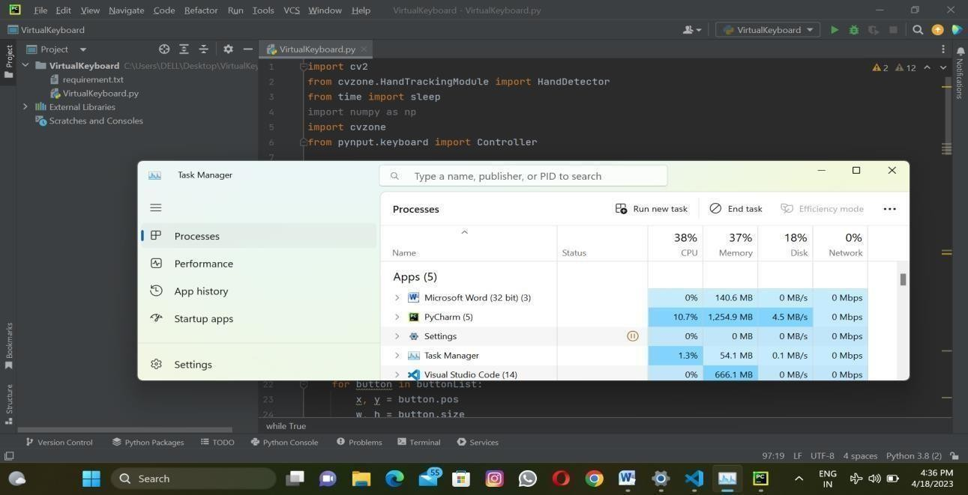

**User Manual**

**Step 1: Run the Project**

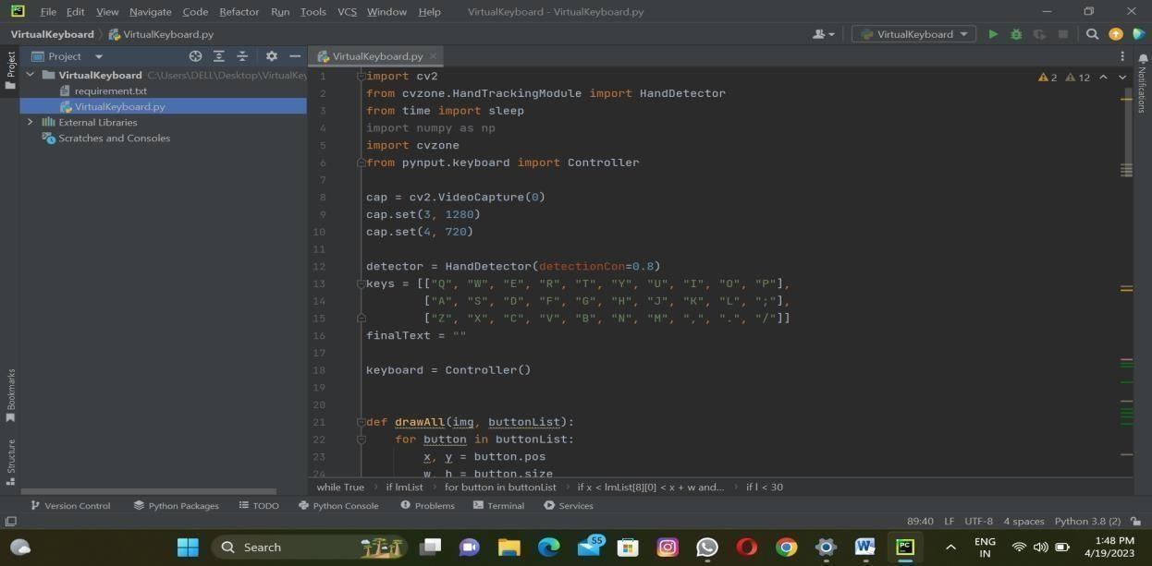

**Step 2: Open camera and display the virtual keyboard**

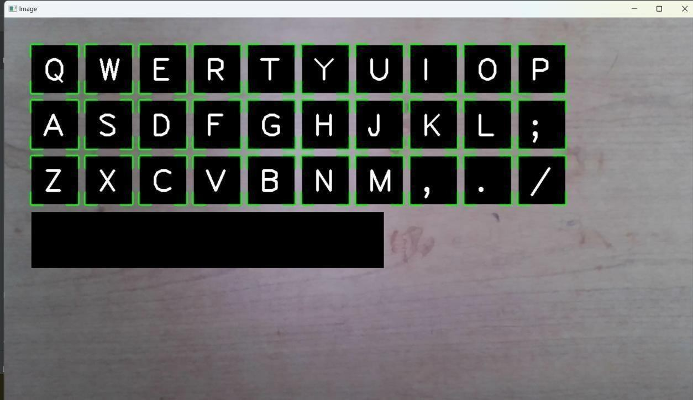

**Step 3: Now recognition the hand**

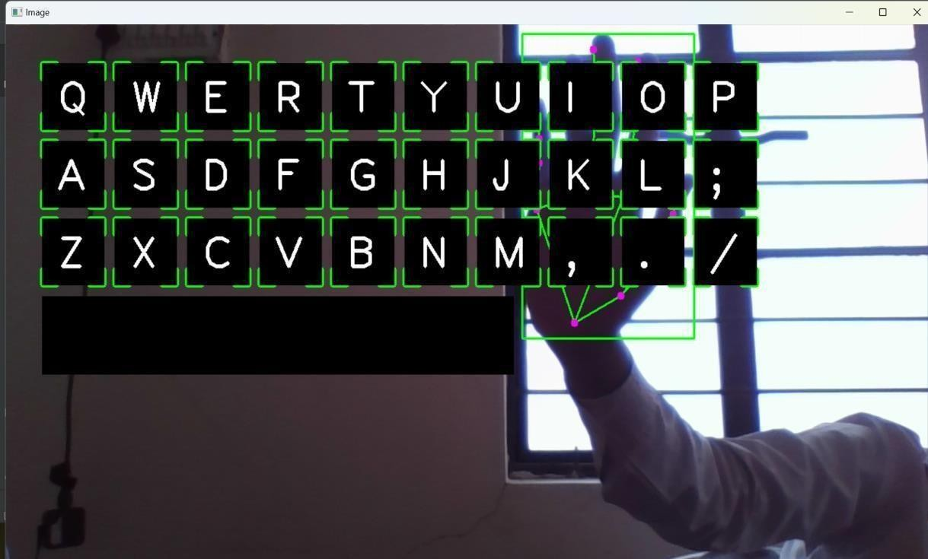

**Step 4: Then type the words.**

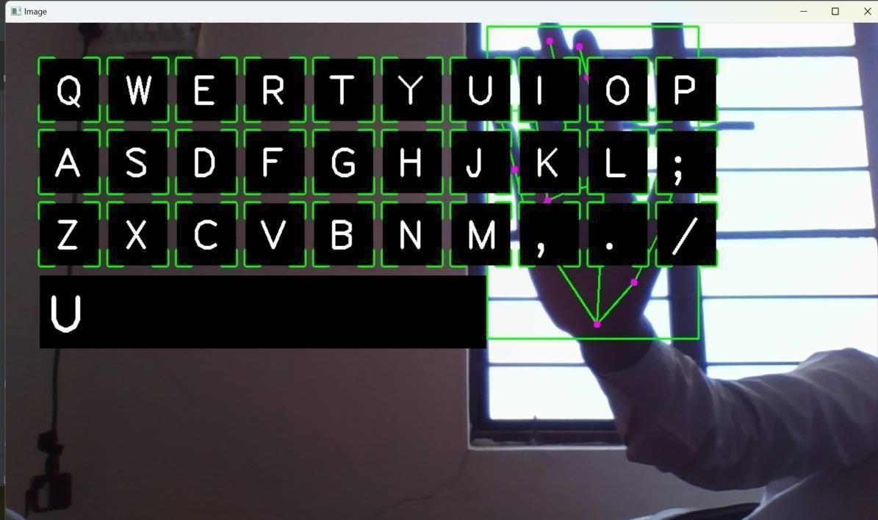

**Result**

1. We have type a word:

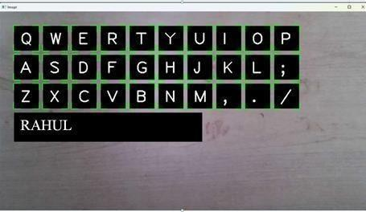

1. Now we will press some words

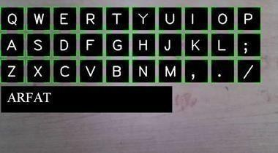

1. Now we type another name

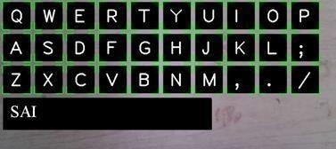

**Application**

1. **Accessibility:**

A virtual keyboard based on finger recognition can provide an alternative input method for individuals who have difficulty using traditional physical keyboards, such as those with motor impairments.

1. **Convenience:**

A virtual keyboard can be used on a variety of devices, such as smartphones, tablets, and laptops, without the need for an external keyboard.

1. **Hygiene:**

In public spaces, a virtual keyboard can reduce the risk of spreading germs as there is no physical contact with the keyboard.

1. **Security:**

Finger recognition technology can be used as a security feature to authenticate the user and prevent unauthorized access.

## BIBLIOGRPHY

Vantukala VishnuTeja Reddy1, Thumma Dhyanchand2 , Galla Vamsi Krishna3. “Virtual Mouse Control UsingColored Finger Tips and Hand Gesture Recognition” (2020 IEEE-HYDCON).

Jing-Hao Sun,Ting-Ting Ji,Shu-Bin Zhang “Research on the Hand Gesture Recognition Based on Deep Learning”2020 12th International Symposium on Antennas, Propagation and EM Theory (ISAPE).

Rafael Augusto Da Silva and Antonio Cl “Algorithm for decoding visual gestures for an assistive virtual keyboard”IEEE Latin America Transactions (Volume: 18, Issue: 11, November 2020).

Kadir Akdeniz1 , Zehra C¸ ataltepe “Dynamic and Personalized Keyboard for Eye Tracker Typing” 2020 24thSignal Processing and Communication Application Conference (SIU)

Ue-Hwan Kim, Sahng-Min Yoo, and Jong-Hwan Kim, “I-Keyboard: Fully Imaginary Keyboard on Touch DevicesEmpowered by Deep Neural Decoder”, IEEE Transactions on Cybernetics ( Volume: 51, Issue: 9, September 2021).

Abhilash, S. S., Thomas, L., Wilson, N., &Chaithanya, C. (2018). Virtual Mouse Using Hand Gesture. International Research Journal of Engineering and Technology (IRJET), 5(4), 3903-3906.

Ashok, M. A., Revathi, M. P., & Nirmal, B. (2020). FINGER RECONGITION AND

GESTURE BASED VIRTUAL KEYBOARD. Turkish Journal of Computer and Mathematics Education(TURCOMAT), 11(3), 2237- 2245.

Abhilash, S. S., Thomas, L., Wilson, N., &Chaithanya, C. (2018). Virtual Mouse Using Hand Gesture.International Research Journal of Engineering and Technology (IRJET), 5(4), 3903-3906.